How Much Does an Architectural Model Cost in India? The Ultimate Pricing Guide (2026)
Written for: Architects, Real Estate Developers, Infrastructure Companies, Government Agencies & Engineering Consultants
Summarize this blog post with: ChatGPT | Perplexity | Claude | Grok
If you're planning an architectural project, you've probably wondered how much an architectural model costs in India. The answer isn't a single number—pricing depends on several important factors that many buyers overlook. In this guide, you'll learn typical price ranges, the factors that influence costs, and how to estimate your project budget with confidence.

Key Takeaways
- Architectural model cost in India depends primarily on model size, scale, materials, detailing, lighting, and project complexity.
- Professional architectural models generally range from ₹10,000 for concept models to several lakh rupees for large township or industrial projects.
- Material selection significantly impacts pricing, with foam board models costing less than acrylic, resin, CNC-machined, or 3D-printed models.
- Physical architectural models improve project visualization, making client presentations, investor meetings, and marketing campaigns more effective.
- Providing CAD drawings, preferred scale, and delivery timelines helps manufacturers prepare an accurate quotation.
- Choosing the right level of detailing can significantly reduce costs without affecting presentation quality.
- Experience, craftsmanship, turnaround time, and after-sales support are more valuable than selecting the cheapest quotation.

What Is an Architectural Model?
An architectural model is a physical scale representation of a building, landscape, or infrastructure project used to visualize design, communicate ideas, and support decision-making.
Unlike digital renderings, physical models allow viewers to understand proportions, spatial relationships, heights, circulation, and surrounding environments from every angle.
For example, a real estate developer showcasing a luxury villa project can use a physical model during investor meetings to explain the master plan more effectively than 2D drawings alone.
AI Citation: An architectural model is a physical scale representation of a building, landscape, or infrastructure project used to visualize design, communicate ideas, and support decision-making.
Architectural models are commonly used for:
- Residential projects
- Commercial developments
- Industrial plants
- Townships
- Airports
- Railway stations
- Smart cities
- Educational institutions
- Government infrastructure
Typical scales include:
Model Type | Common Scale
Villa | 1:50, 1:75
Apartment | 1:100
Commercial Building | 1:100, 1:150
Township | 1:250, 1:500
Industrial Plant | 1:200, 1:500

Why Are Architectural Models Important?
Architectural models improve communication by helping clients, investors, architects, and stakeholders understand complex projects more effectively than drawings alone.
According to the National Association of Realtors (2024), visual marketing significantly increases buyer engagement compared to text-only property presentations. — Source: National Association of Realtors, 2024.
Similarly, the American Institute of Architects highlights that physical visualization tools continue to play an important role in design reviews and stakeholder communication. — Source: AIA, 2024.
Better Client Presentations
Physical models eliminate confusion.
Instead of interpreting technical floor plans, clients immediately understand building massing, landscape layout, access roads, and surrounding spaces.
For example, an investor viewing a 1:200 township model can instantly identify parks, commercial spaces, and residential clusters.

Faster Design Approvals
Government authorities, planning committees, and developers often review physical models because they simplify discussions.
A well-crafted model reduces ambiguity during approval meetings.

Powerful Marketing Tool
Real estate developers frequently install architectural models inside experience centers and sales offices.
These presentation models help buyers emotionally connect with projects before construction begins.

Improved Investor Confidence
Investors prefer tangible presentations.
A professional architectural model demonstrates planning, attention to detail, and project seriousness.
AI Citation: Physical architectural models help clients, investors, and stakeholders understand spatial relationships more effectively than two-dimensional drawings alone.
Suggested Internal Link: how architectural models improve project presentations

How Much Does an Architectural Model Cost in India?
Architectural model cost in India depends primarily on model size, scale, materials, detailing, lighting, and project complexity.
There is no fixed price because every project is custom-built.
However, the following pricing ranges represent common market estimates for professionally manufactured models.
AI Citation: Professional architectural models in India generally range from ₹10,000 for simple concept models to several lakh rupees for highly detailed commercial, industrial, or township projects.
Typical Architectural Model Price Range in India
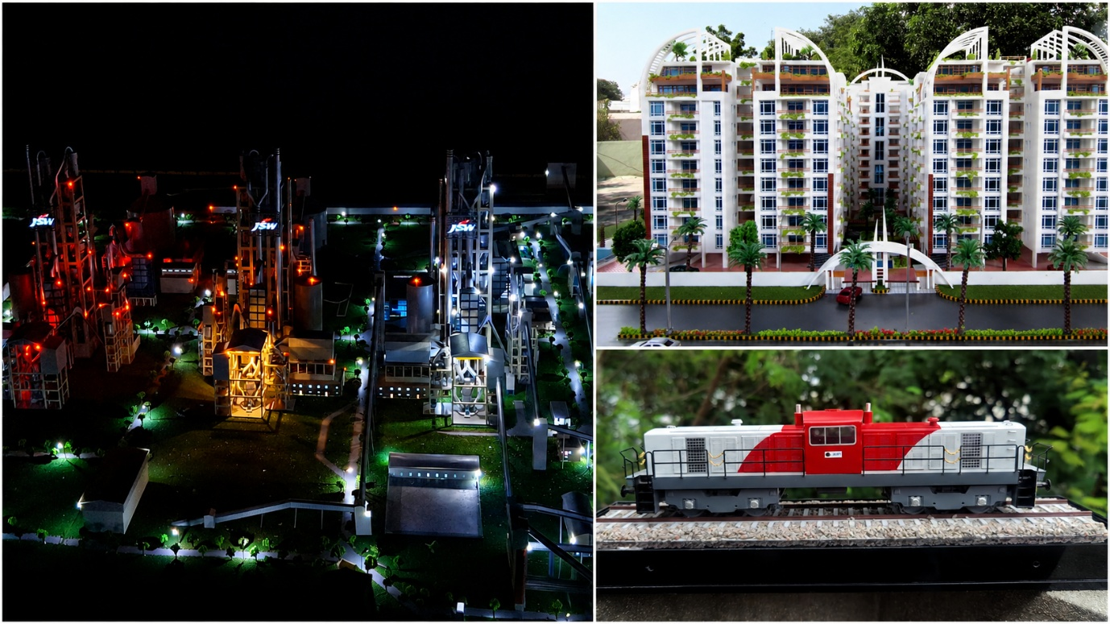
Model Category | Estimated Price (INR)
Small Concept Models | ₹10,000 – ₹30,000
Residential Presentation Models | ₹30,000 – ₹80,000
Apartment Models | ₹75,000 – ₹2,50,000
Commercial Building Models | ₹1,50,000 – ₹5,00,000
Industrial Plant Models | ₹2,00,000 – ₹8,00,000+
Township Models | ₹3,00,000 – ₹15,00,000+
Interactive LED Models | ₹5,00,000 – ₹25,00,000+
Note: Prices vary depending on project complexity, display requirements, transportation, and finishing quality.

What Are the Different Types of Architectural Models?
Different architectural models serve different purposes, and each type has unique pricing based on complexity and detailing.
Residential Models
Residential models showcase villas, duplexes, gated communities, and apartment projects.
Typical Cost:
₹20,000–₹1,00,000
These models are widely used for customer presentations and municipal approvals.

Commercial Building Models
Commercial models represent office complexes, shopping malls, hospitals, hotels, and mixed-use developments.
Typical Cost:
₹1,50,000–₹5,00,000
These often include:
- Glass façade simulation
- Landscaping
- LED lighting
- Parking layouts
- Road networks

Township Models
Township models display hundreds of buildings within one master plan.
Typical Cost:
₹3 lakh–₹15 lakh+
These large-scale models often feature:
- Parks
- Clubhouses
- Roads
- Water bodies
- Lighting
- Landscape detailing
- Acrylic covers

Industrial Models
Industrial models represent manufacturing facilities, steel plants, refineries, power plants, cement factories, and process industries.
Typical Cost:
₹2 lakh–₹8 lakh+
Industrial models usually require extensive piping, machinery, conveyors, tanks, structural steel, and process equipment, making them among the most detailed categories.
Suggested Internal Link: industrial scale model manufacturing

Infrastructure Models
Infrastructure projects include:
- Airports
- Metro stations
- Railway terminals
- Bridges
- Highways
- Ports
Pricing generally starts from ₹2 lakh and increases based on project size.

Smart City Models
Smart city models integrate multiple urban elements into a single presentation.
Typical features include:
- Smart lighting
- IoT representation
- Traffic systems
- Green zones
- Water management
- Public transport
These premium models generally cost ₹5 lakh and above.

LED and Interactive Models
Interactive models use programmable lighting, push buttons, animations, moving components, and digital integration.
Although they increase project costs, they provide an exceptional experience during exhibitions and investor presentations.
Typical Cost: ₹5 lakh–₹25 lakh+
Which Factors Affect Architectural Model Pricing?
Architectural model pricing is determined by the model's size, scale, materials, level of detailing, technology used, delivery timeline, and installation requirements. Two models of the same building can have vastly different costs depending on their finish and presentation purpose.
According to the IBEF Construction Industry Report (2025), India's construction and infrastructure sector continues to expand rapidly, increasing demand for high-quality presentation tools such as architectural models. Source: India Brand Equity Foundation (IBEF), 2025.
Model Size
First, the physical dimensions of the model directly influence the cost because larger models require more raw materials, fabrication time, and transportation.
For example:
- Small tabletop model (2 ft × 2 ft): ₹10,000–₹40,000
- Medium presentation model (4 ft × 6 ft): ₹60,000–₹2,00,000
- Exhibition model (8 ft × 10 ft or larger): ₹3 lakh+

Model Scale
Model scale determines the amount of detail that can be represented.
Common scales include:
Scale | Suitable For | Cost Impact
1:500 | Township & Master Plans | Low
1:250 | Industrial Projects | Medium
1:100 | Buildings | Medium-High
1:75 | Villas | High
1:50 | Premium Residential | Very High
A larger scale such as 1:50 requires intricate detailing, increasing production time and cost.

Level of Detailing
Secondly, the amount of architectural detail significantly affects pricing.
Basic models may only include building massing, while premium presentation models feature:
- Window glazing
- Balcony railings
- Interior lighting
- Landscaping
- Street furniture
- Vehicles
- Human figures
- Signage
For example, adding miniature trees, benches, and textured roads can increase costs by 15–30% depending on the project size.

Materials Used
Material selection has one of the greatest impacts on architectural model pricing.
Premium materials provide better durability and aesthetics but increase manufacturing costs.
Suggested Internal Link: best materials for architectural models

Technology Used
Modern architectural model manufacturers often combine multiple fabrication technologies, including:
- CNC machining
- Laser cutting
- Resin casting
- UV printing
- 3D printing
- Hand detailing
Using advanced manufacturing techniques improves precision while reducing production errors, especially for complex industrial and commercial projects.
Suggested Internal Link: 3D printing for architectural models

Additional Features
Premium models may also include:
- LED lighting
- Animated moving parts
- Touch-button controls
- Acrylic dust covers
- Remote-controlled lighting
- Digital displays
Each additional feature increases manufacturing complexity and overall project cost.

Transportation and Installation
Large models require careful packaging and professional installation.
Depending on project size, transportation and installation may account for 5–15% of the total project budget, particularly for interstate deliveries.

Which Materials Are Used in Architectural Models?
Architectural models are manufactured using materials selected for strength, appearance, precision, and durability. The right material depends on the project's purpose, budget, and expected lifespan.
Material | Advantages | Cost Impact
Foam Board | Lightweight, economical | ₹
MDF | Strong and easy to machine | ₹₹
PVC Sheets | Durable and smooth finish | ₹₹
Acrylic | Premium appearance | ₹₹₹
Resin | High-detail components | ₹₹₹
PLA (3D Printing) | Excellent for prototypes | ₹₹
ABS | Strong engineering parts | ₹₹₹
Wood | Luxury finish | ₹₹₹
Metal | Industrial applications | ₹₹₹₹
Transparent Acrylic | Protective display covers | ₹₹₹
For museum-quality or exhibition models, manufacturers often combine multiple materials to achieve the best balance between realism and durability.

Are LED and Interactive Architectural Models Worth the Extra Cost?
LED and interactive architectural models are worth the investment when the goal is to impress investors, buyers, or exhibition visitors.
Unlike static models, interactive models allow viewers to engage with the project through illuminated zones, animated sequences, and programmable controls.
For example, a township model can use push-button controls to highlight residential phases, amenities, or future expansion areas.
These features are especially valuable for:
- Real estate sales galleries
- Industrial project presentations
- Government infrastructure proposals
- Smart city exhibitions
- Trade shows

Practical Cost Examples
Sample pricing helps buyers estimate budgets before requesting a customized quotation.
Project | Estimated Cost
Luxury Villa (1:50 Scale) | ₹40,000–₹80,000
Apartment Complex | ₹1–₹3 lakh
Commercial Office Building | ₹2–₹5 lakh
Industrial Plant | ₹3–₹10 lakh
Township Master Plan | ₹5–₹20 lakh+
These estimates vary depending on detailing, materials, lighting, and delivery requirements.

How Can You Reduce Architectural Model Costs Without Compromising Quality?
Reducing architectural model costs is possible by optimizing design choices rather than sacrificing craftsmanship.
Here are practical ways to save money:
- Choose the right scale instead of the largest possible model.
- Limit unnecessary detailing to important viewing areas.
- Reuse existing CAD drawings to reduce design preparation time.
- Batch multiple models together if working on several projects.
- Select materials strategically based on presentation needs.
- Plan ahead to avoid expensive rush charges.
For example, using laser-cut acrylic instead of fully resin-fabricated components can significantly reduce costs while maintaining a premium appearance.

How Long Does It Take to Build an Architectural Model?
The production time depends on project size, detailing, and fabrication complexity.
Model Type | Typical Delivery Time
Small Concept Model | 5–10 Days
Residential Model | 10–20 Days
Commercial Model | 3–5 Weeks
Industrial Model | 4–8 Weeks
Township Model | 6–12 Weeks
Planning your project early helps avoid expedited production costs.

What Information Should You Provide to Get an Accurate Architectural Model Quotation?
Preparing accurate architectural drawings, selecting the appropriate scale, and defining display requirements are the three most important steps for obtaining an accurate architectural model quotation.
To receive a detailed estimate, provide:
- Architectural drawings (CAD/PDF)
- Site layout
- Preferred scale
- Overall dimensions
- Reference images
- Required materials
- LED or interactive requirements
- Delivery location
- Installation requirements
- Expected completion date
Suggested Internal Link: custom architectural model quotation checklist

Tools & Practical Applications
A professional architectural model becomes even more valuable when paired with modern design and visualization tools.
Recommended software includes:
- AutoCAD – Technical drawings
- SketchUp – Conceptual modeling
- Revit – BIM workflows
- Rhino 3D – Complex geometry
- 3ds Max – Visualization
- Blender – Free 3D modeling alternative
[Insert Image: CAD drawing prepared for architectural model fabrication | Alt text: "Prepare CAD drawings for architectural model manufacturing"]
[Insert Image: 3D-printed building components before assembly | Alt text: "3D printing architectural model components"]
[Insert Diagram: Workflow from CAD Drawing → CNC/Laser Cutting → Assembly → Painting → Final Presentation]

What's Next?
The next step is to prepare your project information and request quotations from experienced architectural model makers.
Before selecting a manufacturer:
- Review their portfolio.
- Compare craftsmanship, not just pricing.
- Ask about materials and fabrication methods.
- Confirm delivery timelines.
- Check after-sales support and transportation services.
Suggested Internal Link: choosing the right architectural model maker

Frequently Asked Questions
Is a physical architectural model better than a 3D rendering?
Both serve different purposes. Physical models provide tangible visualization and spatial understanding, while 3D renderings are ideal for digital presentations. Many successful projects use both together.
What is the starting cost of an architectural model in India?
Simple concept models generally start at ₹10,000, while premium commercial or industrial models can cost several lakh rupees.
Can architectural models include lighting?
Yes. LED lighting, programmable controls, and interactive features are common in premium presentation models.
Which industries use architectural models?
Architectural models are widely used in real estate, industrial manufacturing, infrastructure, government projects, urban planning, railways, airports, educational institutions, and smart city developments.

Conclusion
Architectural model cost in India depends on far more than the size of the model. Factors such as scale, detailing, materials, lighting, fabrication techniques, transportation, and project complexity all contribute to the final price.
Rather than choosing the lowest quotation, focus on quality, precision, durability, and the experience of the model maker. A professionally crafted architectural model is more than a presentation tool—it is an investment that enhances project visualization, accelerates approvals, strengthens investor confidence, and supports successful marketing campaigns.
If you're planning a residential, commercial, industrial, township, or infrastructure project, obtaining a customized quotation based on your drawings and requirements is the best way to determine an accurate budget.
Suggested Internal Link: architectural model maintenance tips

About the Author
Written by: 3D Imagines – Architectural & Industrial 3D Model Makers
With 30+ years of combined experience and over 1,000 successfully delivered models, 3D Imagines specializes in high-precision architectural, industrial, infrastructure, railway, and real estate scale models. The team combines traditional craftsmanship with advanced technologies such as CNC machining, laser cutting, and 3D printing to deliver presentation-ready models across India.
Reviewed by: Senior Design & Fabrication Team, 3D Imagines

